DELPHI Simulated Operating Characteristics of Phase 1 Dose Escalation Designs
Report Date and Time: 2021-02-02 21:36:38
Software: DELPHI app version XXX available at: https://bengarski.shinyapps.io/DELPHI/
Objective:
To evaluate the operating characteristics of the following dose escalation designs: <design> 3+3, CRM, and TARGET-CRM.
Methods:
Trial operating characteristics are averaged over <number.trials> 100 simulated trials. Simulated trials have <length(true.tox)> 4 dose levels labelled <dose labels> (-1, 1, 2, 3), starting on dose level <start.level> 1, and assuming true toxicity probabilities of <true.tox> (0.05,0.12,0.20,0.30). The target toxicity probability is <target.tox> 0.2. One patient arrives every <arrival.rate> 15 days on average. The DLT observation period is <cycle.length> 28 days.
<include the following text only if TARGET-CRM and/or CRM is selected>
For the TARGET-CRM and/or CRM design, the prior toxicity probabilities per dose level are <prior> (0.05,0.12,0.20,0.30). The cohort size is <cohort.size> 3 and the maximum sample size <max.N> is 18. Patients belong to one of two cohorts: Cohort A or Cohort B. Patients with pre-specified characteristics (e.g. tumor type, tumor mutation) belong to Cohort B; all other patients belong to Cohort A. The TARGET-CRM design allows enrollment of Cohort B patients at one dose level below the current dose during the DLT observation period of the current cohort of patients. The proportion of patients from Cohort B is <prop.B> 0.1.
Simulated trials using the TARGET-CRM and/or CRM designs are required to have a minimum enrollment of <min.cohortB> 0 Cohort B patients.
Results:
[Template for TWO OR MORE designs]
Accuracy: For each dose level, Figure 1 presents the proportion of simulated trials that a given dose level was selected as the true MTD. The <select design with highest PCS> TARGET-CRM design has greatest probability of selecting the true MTD (dose level <true.MTD> 4). The proportion of correct selection (PCS) of the MTD for the TARGET-CRM design is <PCS> 0.5. The PCS for the 3+3 design is <PCS> 0.318.
Safety: Figure 2 presents the proportion of patients experiencing a DLT for each dose level.
The proportion of patients experiencing a DLT for the 3+3 design is <obs.tox.overall> 0.173, which is lower / greater than the target toxicity probability of <target.tox> 0.2. The proportion of patients experiencing a DLT for the TARGET-CRM design is <obs.tox.overall> 0.138, which is lower / greater than the target toxicity probability of <target.tox> 0.2.
Patient allocation: Figure 3 presents the proportion of patients assigned to each dose level. The <select design with the highest patient allocation for the true.MTD in patient.allocation.table> TARGET-CRM design has the greatest probability of assigning patients at the true MTD (dose level <true.tox> 4). The proportion of patients assigned to the true MTD for the TARGET-CRM design is <patient.allocation.table> 0.50. The proportion of patients assigned to the true MTD for the 3+3 design is <patient.allocation.table> 0.45.
Study duration: Figure 4 presents the mean (+/- standard deviation) study duration in days for each design. The <select design with shortest mean.duration> TARGET-CRM design has the shortest mean study duration. The mean study duration for the 3+3 design is <mean.duration> 608.54 days (standard deviation [SD] <sd.duration> = 31.21). The mean study duration for the TARGET-CRM design is <mean.duration> 588.89 days (<sd.duration> SD=135.85).
Table 1 presents a summary of the operating characteristics for each design.
Sample size: The mean total sample size for the 3+3 design is <mean.obs.N> 15.36 <min.obs.N; max.obs.N> (range=9-21). The mean total sample size for the TARGET-CRM design is <mean.obs.N> 18 <min.obs.N; max.obs.N>(range=18-18).
Enrollment of Cohort B patients (TARGET-CRM only): The proportion of patients in the population belonging to Cohort B is <prop.B> 0.2. The mean number of Cohort B patients enrolled during the DLT observation period is <mean.cohortB> 0.3 (<sd.cohortB> SD=0.541).
[Template for ONE design]
Accuracy: For each dose level, Figure 1 presents the proportion of simulated trials that a given dose level was selected as the true MTD. The proportion of correct selection (PCS) of the MTD for the <design> TARGET-CRM design is <PCS> 0.5.
Safety: Figure 2 presents the proportion of patients experiencing a DLT for each dose level. The proportion of patients experiencing a DLT for the <design> TARGET-CRM design is <obs.tox.overall> 0.138, which is lower / greater than the target toxicity probability of <target.tox> 0.2.
Patient allocation: Figure 3 presents the proportion of patients assigned to each dose level. The proportion of patients assigned to the true MTD (dose level <true.tox> 4) for the <design> TARGET-CRM design is <patient.allocation.table> 0.50.
Study duration: Figure 4 presents the mean (+/- standard deviation) study duration in days for each design. The mean study duration for the <design> TARGET-CRM design is 608.54 days (standard deviation [SD] = 31.21).
Table 1 presents a summary of the operating characteristics for each design.
Sample size: The mean total sample size for the <design> TARGET-CRM design is <mean.obs.N> 18 <min.obs.N; max.obs.N> (range=18-18).
<Include only if TARGET-CRM design is selected> Enrollment of Cohort B patients: The proportion of patients in the population belonging to Cohort B is <prop.B> 0.2. The mean number of Cohort B patients enrolled during the DLT observation period is <mean.cohortB> 0.3 (<sd.cohortB> SD=0.541)

Figures
Figure 1: Proportion of simulated trials selecting each dose level as the true MTD. The true MTD is highlighted with a dark outline.
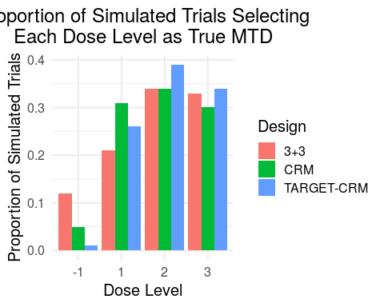

Figure 2: Proportion of patients experiencing a DLT per dose level. The target toxicity probability is denoted by the horizontal dashed line. The true MTD is highlighted with a dark outline.
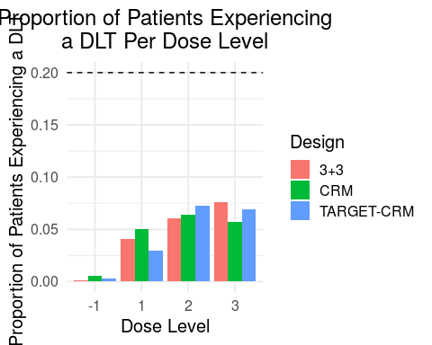

Figure 3: Proportion of simulated trials selecting each dose level as the true MTD. The true MTD is highlighted with a dark outline.
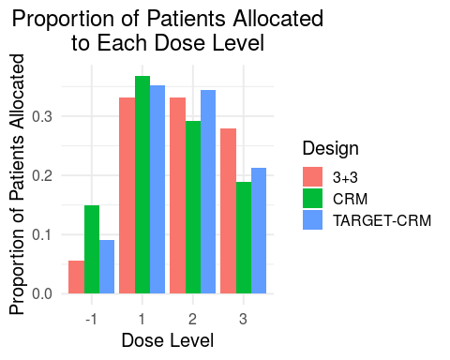

Figure 4: The mean (+/- 1 standard deviation [SD]) study duration in days.

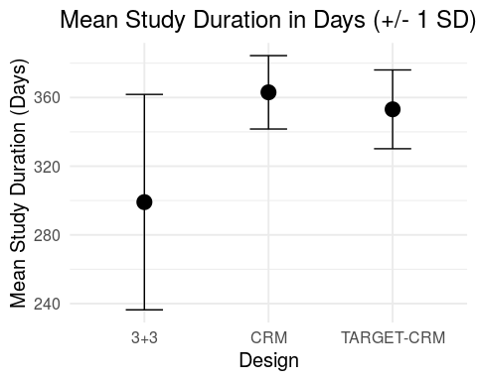

Table 1: Summary of operating characteristics for the selected designs.

Operating Characteristic | 3+3 | TARGET-CRM | CRM
Proportion of correct selection (PCS) | 0.340 | 0.390 | 0.340
True MTD | 3.000 | 3.000 | 3.000
Proportion of trials selecting dose 1 as true MTD | 0.120 | 0.010 | 0.050
Proportion of trials selecting dose 2 as true MTD | 0.210 | 0.260 | 0.310
Proportion of trials selecting dose 3 as true MTD | 0.340 | 0.390 | 0.340
Proportion of trials selecting dose 4 as true MTD | 0.330 | 0.340 | 0.300
Proportion of patients experiencing a DLT overall | 0.179 | 0.174 | 0.176
Proportion of patients experiencing a DLT at dose 1 | 0.002 | 0.003 | 0.005
Proportion of patients experiencing a DLT at dose 2 | 0.041 | 0.030 | 0.050
Proportion of patients experiencing a DLT at dose 3 | 0.060 | 0.073 | 0.064
Proportion of patients experiencing a DLT at dose 4 | 0.076 | 0.069 | 0.057
Mean total sample size per trial | 12.750 | 18.440 | 18.660
Minimum total sample size per trial | 9.000 | 18.000 | 18.000
Maximum total sample size per trial | 18.000 | 20.000 | 20.000
Proportion of patients enrolled at dose 1 | 0.056 | 0.092 | 0.150
Proportion of patients enrolled at dose 2 | 0.332 | 0.352 | 0.368
Proportion of patients enrolled at dose 3 | 0.332 | 0.344 | 0.292
Proportion of patients enrolled at dose 4 | 0.280 | 0.212 | 0.190
Mean study duration in days | 299.080 | 353.122 | 363.020
Standard deviation of study duration in days | 62.721 | 22.936 | 21.369
Mean # of cohort B patients enrolled during DLT observation period (TARGET-CRM only) | NA | 0.540 | 0.000
Standard deviation of # of cohort B patients enrolled during DLT observation period (TARGET-CRM only) | NA | 0.731 | 0.000

